Q1. Explain Inheritance in java programming?

Ans: Passing properties from one class into another class

Properties may be member data and member function

In case of inheritance member data should not be private

Java Does not support multiple inheritance through the class

Java Does not support Operator overloading

Java Does not support inline function

Java Does not support friend function

Java does not support virtual or pure virtual function

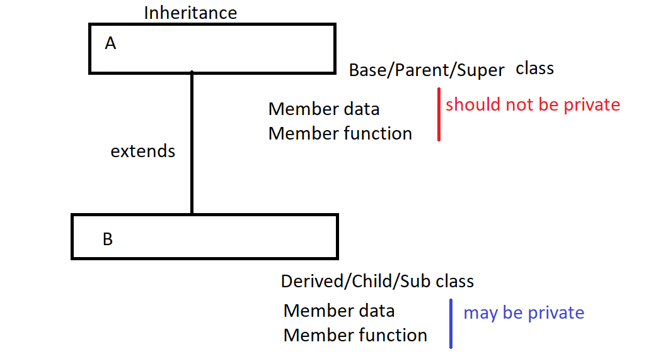

Syntax:

class Parent{

Member data

Member function

}

class Child extends Parent{

Member data

Member function

}

//Example of single inheritance extends keyword for single inheritance

class AB{

static{

System.out.println("This is parent class");

}

}

class B extends AB{

static{

System.out.println("This is child class ");

}

}

class Bc extends B{

static{

System.out.println("This is subchild class ");

}

}

class MainB extends Bc{

public static void main(String args[]){

AB obj=new AB();

System.out.println("This main method");

}

}

